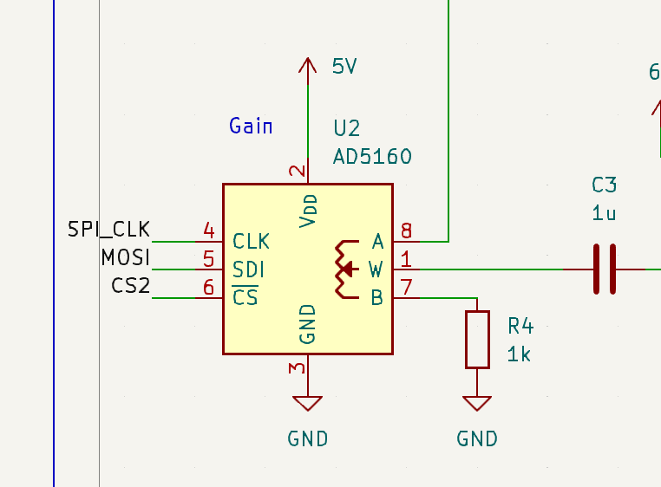
Add decoupling capacitors to U2 and U5
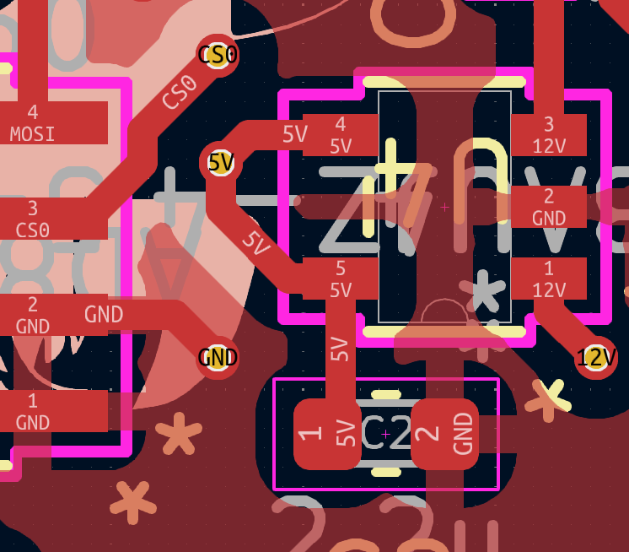
Add more vias to connect 5V on top layer to 5V plane on 3rd layer

